

**MAD PROJECT REPORT**

**SUBMITTED BY: DANIYAL AWAN(20SW107)**

**SAIFULLAH SHAIKH(20SW119)**

**RECIPE APP**

**APP NAME: FOOD MANUEL**

**Real Life Problem Identification:**

Users might find it difficult to navigate through the app, especially if the recipe categories and search options are not intuitive. If the search feature is slow or doesn't provide accurate results, users might get frustrated. Aesthetically unpleasing design or lack of engaging visuals can deter users from exploring the app further. If the recipes provided are incorrect or inconsistent, users might lose trust in the app's content. Lack of features for users to save favorite recipes, create shopping lists, or customize their profiles. Interactive elements like cooking timers, step-by-step guides, or user reviews might be missing, reducing user engagement.

**Proposed Solution:**

Intuitive Navigation: Redesign the app's navigation to make it more user-friendly and intuitive, allowing users to easily explore recipes and categories.

Efficient Search: Implement a powerful search algorithm to ensure quick and accurate results. Include filters for dietary preferences, cuisine types, and cooking time.

Visual Redesign: Improve the app's visual appeal with high-quality images, appealing typography, and a cohesive color scheme to enhance user engagement.

Optimize Loading Times: Reduce image sizes, implement lazy loading, and use caching techniques to speed up content loading times.

Bug Fixes: Conduct rigorous testing to identify and fix bugs, ensuring a stable and seamless user experience.

**Responsive User Interface**:

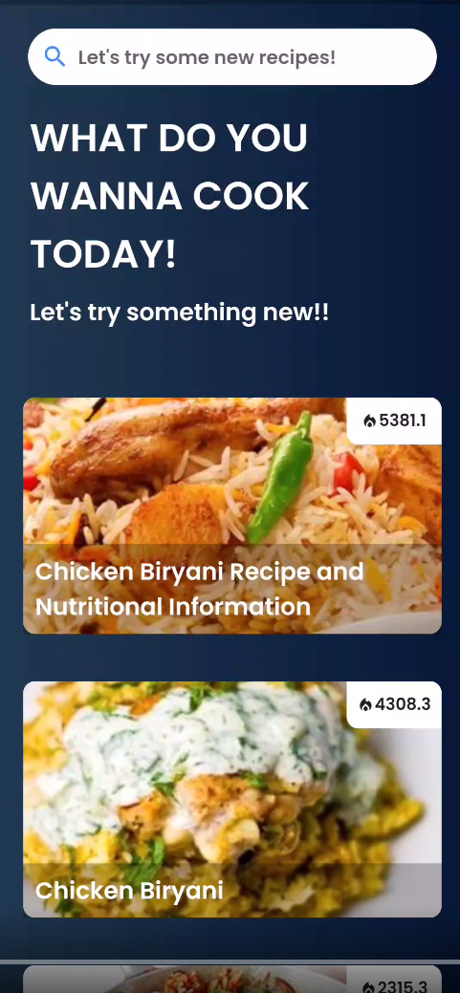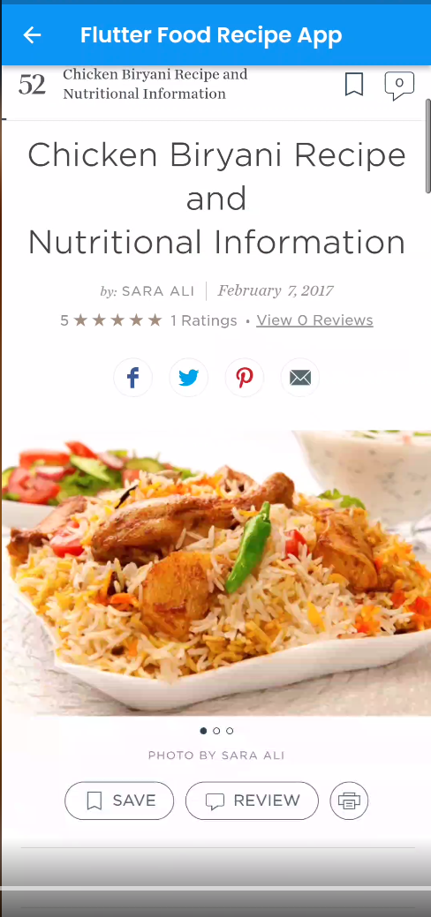

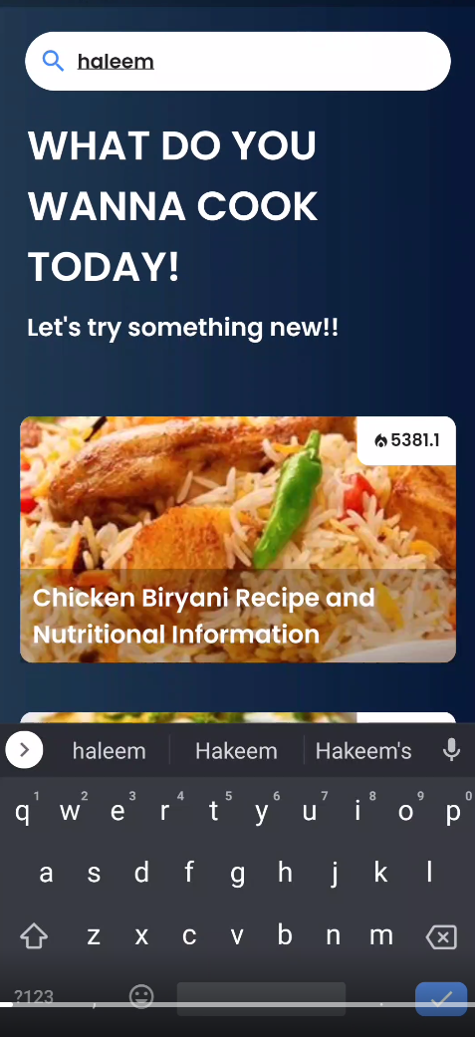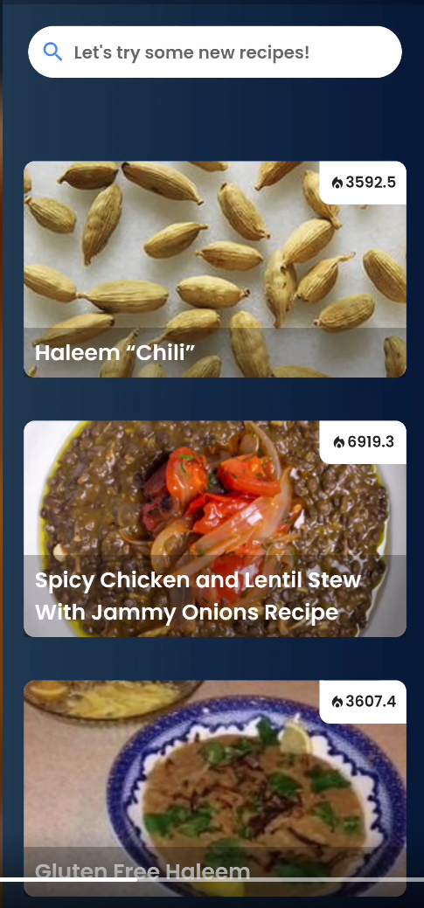

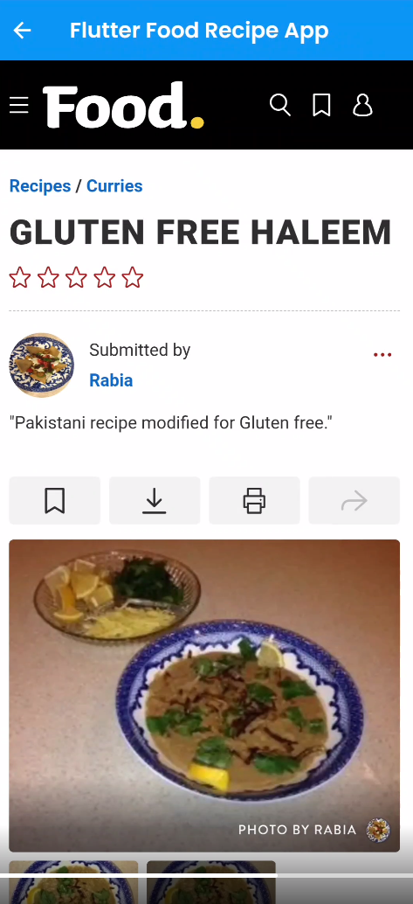

**API Used:**

**EDAMAM:**

This API was used for getting the data of recipes for display.

**WEBVIEW:**

This plugin was used to entertain WebView of recipes inside the app.

